

To: Delegated decisions of the Board Member, Finance and Efficiency

Date: 2nd December 2011

Report of: Head of Corporate Assets

Title of Report: LETTING OF RAMSAY HOUSE, ST EBBES STREET, OXFORD

Summary and Recommendations

Purpose of report: To seek approval to the letting of 2nd Floor Ramsay House, St Ebbe’s Street, Oxford

Key decision? No

Executive lead member: Councillor Ed Turner

Report approved by: Steve Sprason

Finance: Nigel Kennedy

Legal: Steve Smith

Recommendation(s): The Executive member is RECOMMENDED to:-

- Approve the proposed letting of the second floor of Ramsay House, 10 St Ebbe’s Street Oxford to Tenant A on the terms as detailed in the Not for Publication Appendix of this report and otherwise on terms and conditions to be approved by the Head of Corporate Assets.

- Grant approval to the Head of Corporate Assets to vary the proposed rent as detailed in this report provided the transaction continues to represent best consideration.

Appendices

Appendix 1 - Plan of Site
Appendix 2 - Risk Register
Appendix 3 - Not for publication

Background

- This report seeks approval to grant a new lease of premises owned by Oxford City Council and hatched on the plan attached at Appendix 1.

- The property has been occupied by Oxford City Council as an administrative office building and is due to be vacated in March 2012 as a consequence of the Offices for the Future Project.

- The building has been marketed since March 2011 by the appointed agents, VSL and Partners, on a both a long leasehold and ‘to let’ basis. The following initiatives have been undertaken:

  - Marketing board on site
  - A4 printed glossy brochure with electronic pdf version
  - Advertisement in the Oxford Times ‘In Business’ Magazine
  - Online advertisement on EG property link
  - Online advertisement on VSL’s web site

- There has been little interest in a long leasehold sale at a reasonable level and therefore the agents have advised that the Council move forward on the basis of the proposed letting.

- The transaction will allow for a new lease to be agreed, and allows time for a planning application to be made ahead of the building vacation date to ensure that any void period is minimised.

- The transaction will ensure that no refurbishment cost will be required by the landlord.

  - In summary, the proposed letting includes granting, on commercial terms, a new lease broadly on the terms as set out in the confidential not for publication Appendix 3.

Planning

- The letting will be subject to planning consent for a change of use being granted. Informal discussions have been held with the Planning Team and subject to their consideration of a detailed planning application in due course, no issues have been raised to suggest that this will be a bar to the letting.

Issues

- The letting would allow for the property to be marketed for an investment sale to create capital receipt if required by the Council at a point in the future.

Risk Implications

- A risk assessment has been undertaken and the risk register is attached as Appendix 2.
Sustainability and Climate Change Implications

- The vacation of the property by the Council will save 150 tonnes of CO2 per year which will contribute to the Council’s current annual target of saving 240 tonnes of CO2.

Equalities Implications

- No implications.

Financial Implications

- The terms allow for the building to be refurbished without any capital outlay by the Council.

- The proposal, as outlined in the confidential not for publication Appendix 3, will provide substantial income after the rent free period has expired. It will also ensure that the costs of holding the building vacant will be minimised.

- The tenant will pay the Council’s reasonable legal and surveyors fees incurred.

- Appropriate due diligence on the prospective tenants accounts has been undertaken and we have confirmed that the covenant is acceptable to a large range of insitutional investors.

- The tenant will provide a construction bond for the period of the works.

Legal Implications

- The power to let the premises is contained within S123 of the Local Government Act 1972 for best consideration. The property has been fully marketed with appropriate certification from the Council’s advisors being provided.

Name and contact details of author: Julia Castle
Corporate Assets
jcastle@oxford.gov.uk
Extension: 2223

Version number: 2

Appendix 1 – Plan of Premises

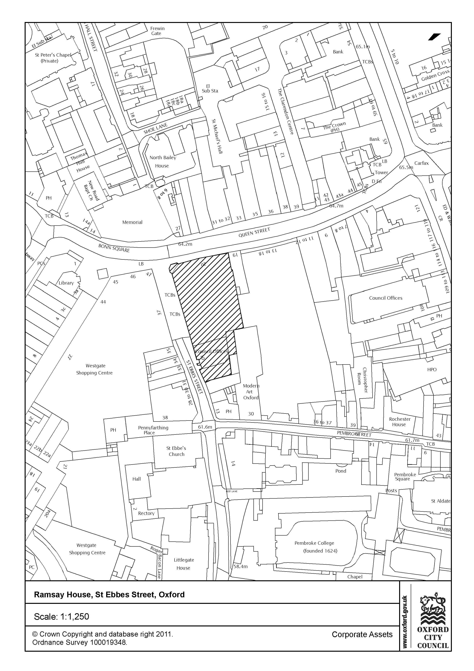
Appendix 2 CEB Report Risk Register – Approval to grant a lease on Ramasy House, St Ebbes Street, Oxford
Risk Score Impact Score: 1 = Insignificant; 2 = Minor; 3 = Moderate; 4 = Major; 5 = Catastrophic
Probability Score: 1 = Rare; 2 = Unlikely; 3 = Possible; 4 = Likely; 5 = Almost Certain

No. | Risk Description  Link to Corporate Objectives | Gross Risk |  | Cause of Risk | Mitigation | Net Risk |  | Further Management of Risk:  Transfer/Accept/Reduce/Avoid |  | Monitoring Effectiveness |  |  |  | Current Risk
1. | Negotiations fail with proposed Tenant A | I  4 | P  3 | Tenant/OCC fails to agree legal terms. | Mitigating Control:  Close contact during procurement process.  Level of Effectiveness:  (HML) H | I  3 | P  2 | Action:  Ongoing contact throughout process to ensure parties still interested.  Action Owner:  Julia Castle | Outcome Required:  Successful negotiation.  Milestone Date:  December 2011 | Q  1 | Q  2 | Q  3 | Q4 | I | P
2 | Negotiations fail with proposed Tenant A | I  4 | P  4 | The tenants structural survey highlights unforeseen issues | Mitigating Control:  Close contact during process.  Level of Effectiveness:  (HML) L | I  3 | P  2 | Action:  Liaise with tenant to overcome any issues which may arise  Action Owner  Julia Castle | Outcome Required:  No issues arise.  Milestone Date December 2011 | Q  1 | Q  2 | Q  3 | Q4 | I | P
3. | Negotiations fail with proposed Tenant A | I  5 | P  3 | Planning consent for change of use is not granted | Mitigating Control:  Close contact between tenant, and Oxford City Council internal teams during planning process.  Level of Effectiveness:  (HML) H | I  4 | P  2 | Action:  Ongoing contact throughout process to ensure consent is granted  Action Owner:  Julia Castle | Outcome Required:  Successful negotiation.  Milestone Date:  March 2012 | Q  1 | Q  2 | Q  3 | Q4 | I | P

